Planning Proposal (PP004)

Worrigee Urban Release Area

Proposed Large Lot Residential Zoning and Associated LEP Changes

Prepared by

Planning and Development Services Group

Shoalhaven City Council

June 2015

File 49572E



Shoalhaven City Council

PO Box 42

NOWRA NSW 2541

telephone (02) 4429 3570

e-mail [council@shoalhaven.nsw.gov.au](mailto:council@shoalhaven.nsw.gov.au)

internet [www.shoalhaven.nsw.gov.au](http://www.shoalhaven.nsw.gov.au)

Disclaimer

**Disclaimer**

Every effort has been made to provide accurate and complete information. However, Shoalhaven City Council assumes no responsibility for any direct, indirect, incidental or consequential damages arising from the use of information in this document.

**Copyright Notice**

No part of this publication may be reproduced in any form or stored in a database or retrieval system, or transmitted or distributed in any form by any means electronic, mechanical photocopying, recording, or otherwise without written permission from Shoalhaven City Council. All rights reserved.

Copyright © 2015, Shoalhaven City Council.

Contents

1 Introduction 4

1.1 Subject Land 4

1.2 Site Context 4

2. Objectives and intended outcomes (Part 1) 7

3. Explanation of provisions (Part 2) 7

4. Justification of objectives, outcomes and processes (Part 3) 9

4.1 Need for the Planning Proposal (Section A) 9

4.1.1 Is the Planning Proposal a result of any strategic study or report? 9

4.2 Relationship to strategic planning framework (Section B) 9

4.3 Environmental, Social and Economic Impact (Section C) 11

4.4 State and Commonwealth Interests (Section D) 12

5. Mapping (Part 4) 12

6. Community consultation (Part 5) 12

7 Project timeline (Part 6) 12

Attachment A: Council resolution to prepare a Planning Proposal 13

Attachment B: Worrigee URA Flood Study 14

Attachment C: State Environmental Planning Policies 15

Attachment D: Checklist of Ministerial Directions 16

**Figures**

Figure 1 - Location of Subject Land 4

Figure 2 - Existing Land Use Zones 5

Figure 3 - Aerial Map 6

Figure 4 - Flood Planning Area 6

Figure 5 - Proposed Zoning 8

Figure 6 - Proposed Minimum Lot Size 8

# 1 Introduction

This Planning Proposal (PP) seeks to change the zoning of land within the Worrigee Urban Release Area (URA) to provide for large lot residential development. Council’s preference is for an R5 Large Lot Residential zone within the URA if the associated Native Vegetation Act provisions are exempt on the basis of a “substantial character determination” (i.e. the URA is deemed to be more urban in character than rural).

## 1.1 Subject Land

The subject land is located approximately 8 km south east of Nowra CBD as shown in Figure 1 below. The subject land comprises two lots that form the area identified in the Nowra-Bomaderry Structure Plan as the Worrigee URA. The current URA covers an area of 33 hectares and includes the following lots which are in separate ownership:

* Lot 586 DP 1048099
* Lot 587 DP 1048099

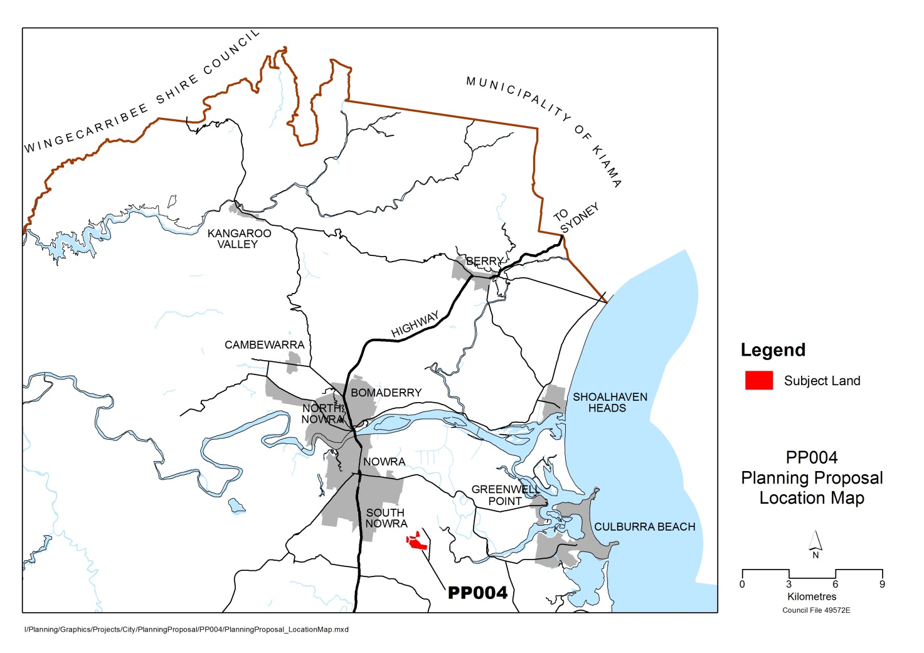

Figure 1 - Location of Subject Land

## 1.2 Site Context

The Worrigee URA was originally identified in the *Nowra-Bomaderry Structure Plan* which was adopted by Council in October 2006 and endorsed by the State Government in early 2008. The land was rezoned to part R1 General Residential and Part RE2 Private Recreation under Shoalhaven Local Environmental Plan (LEP) 2014.

The current zones, as shown in Figure 2, were partially based on a previous proposal for the site that included a golf course and residential development of approximately 392 lots. Shoalhaven LEP 2014 also identifies the land as an “Urban Release Area” for the purposes of Part 6 of the LEP.

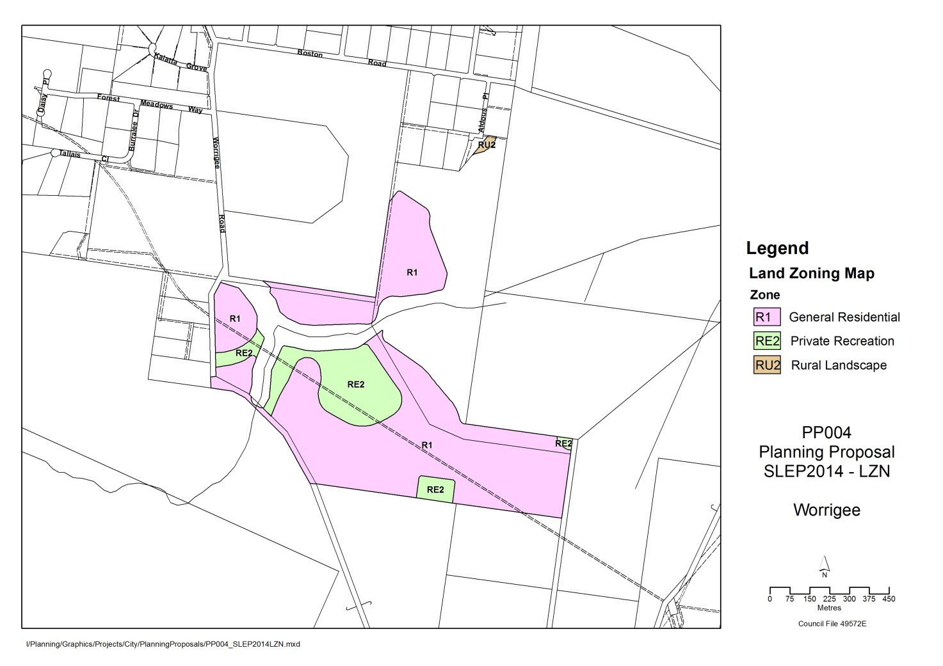

Figure 2 - Existing Land Use Zones

The current zones are somewhat out of character with the surrounding land use / rural fringe setting which is predominately R5 Large Lot Residential, RU2 Rural Landscape and Environmental Protection Zones. Subsequently, Council and landowners within the URA have resolved to undertake a PP that provides for a development outcome that is more consistent with the surrounding land uses.

As shown in Figure 3, the URA is adjoined by large lot residential development and the Shoalhaven Memorial Gardens & Lawn Cemetery on its northern and western boundaries. The southern, and eastern boundaries, and part of the western boundary are heavily vegetated and are predominately NSW National Parks land. The URA is currently only accessible from the north from Worrigee Road, with proposed entrances to the land from Worrigee Road and Aldous Place. As shown in Figure 4 below, large parts of the URA are identified as Flood Planning Area under Shoalhaven LEP 2014.

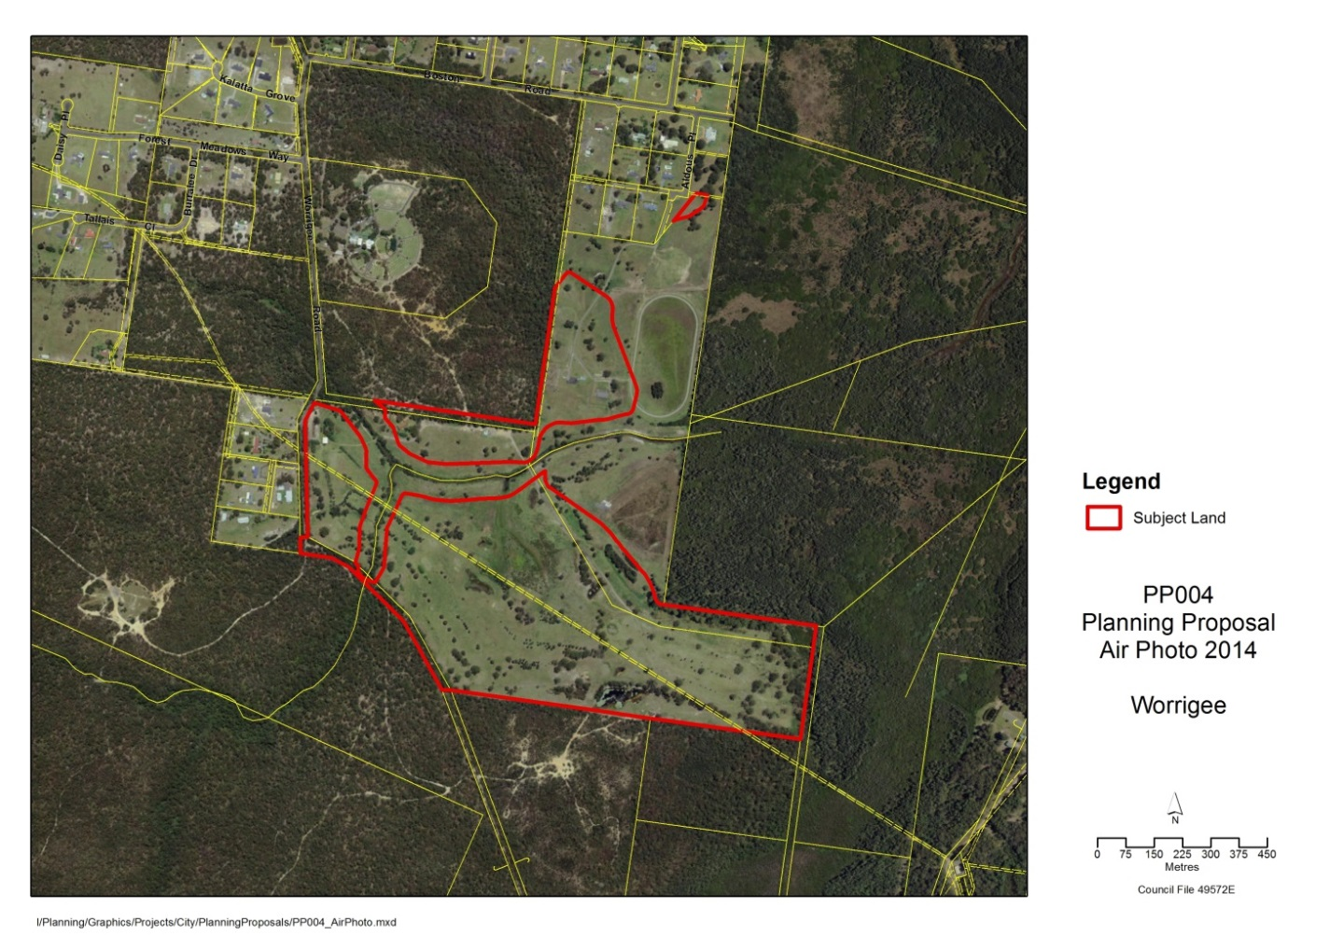

Figure 3 - Aerial Map

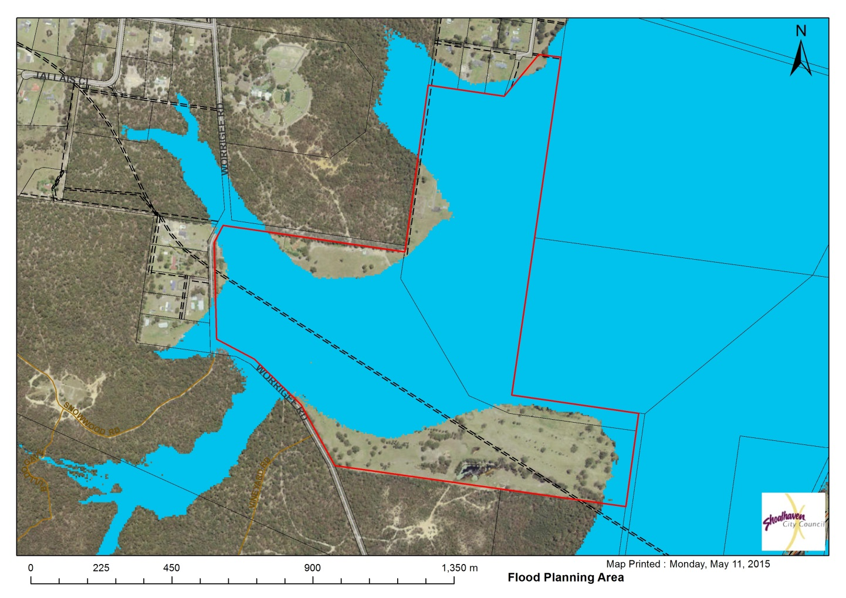

Figure 4 - Flood Planning Area

# 2. Objectives and intended outcomes (Part 1)

The primary objective of this PP is to undertake an amendment to Shoalhaven LEP 2014 to facilitate large lot residential development that is sympathetic to the characteristics of the site.

The PP seeks to rezone the R1 and RE2 zoned land to an R5 Large Lot Residential zone, with a minimum lot size of 2,500m2. This amendment will also correct a minor zoning error in the north-eastern corner of Lot 586 DP 1048099 where a small portion of land (not flood affected) is zoned RU2 Rural Landscape and has been previously overlooked for a Large Lot Residential zoning (i.e. R5 Large Lot Resident).

As the proposal will significantly reduce the potential development yield on the site, the PP also seeks to remove the subject land from the Urban Release Area overlay in Shoalhaven LEP 2014.

The PP will result in a residue lot that is part RU2 Rural Landscape, part E2 Environmental Conservation (riparian corridor) and part E3 Environmental Management. Council’s preference is for the E3 Environmental Management land to be dedicated to NSW National Parks and Wildlife Service (subject to confirmation). As the residue lot is smaller than 40ha, and wholly within a high hazard flood area, the remaining RU2 and E2 land will need to be attached to one of the large lot residential lots. Alternatively, if the E3 land remains in private ownership, the entire residue lot would need to be attached to one of the residential lots.

The areas that are currently zoned RE2 and are intended to be zones R5 contain potential constraints and as such need to be considered and managed accordingly. It is intended that these areas also be identified on the Clauses overlay (and supported by a local Clause) or on the Natural Resources Sensitivity overlay.

# 3. Explanation of provisions (Part 2)

As mentioned above, the subject land shown in Figure 2 is currently zoned part R1 General Residential, part RE2 Private Recreation and part RU2 Rural Landscape. It is proposed to amend Shoalhaven LEP 2014 to rezone the land to R5 Large Lot Residential with a minimum lot size of 2,500m2. The proposed zones and lot sizes are shown in Figure 5 and Figure 6 below.

The supporting Development Control Plan Chapter will restrict development in the areas currently zoned RE2, due to the known constraints of the land. However, it is considered appropriate to include provisions in the LEP that flag the areas as being constrained, and Council intend to liaise with the Department of Planning and Environment to determine the most appropriate provisions prior to the exhibition of the Planning Proposal.

The PP also seeks to remove the subject land from the Urban Release Area overlay and therefore removed the provisions of Part 6 in Shoalhaven LEP 2014 applying to the land.

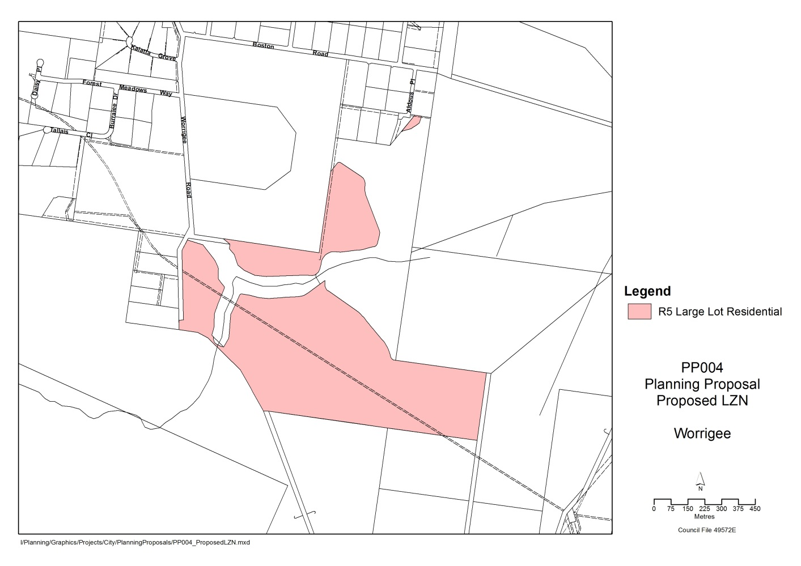

Figure 5 - Proposed Zoning

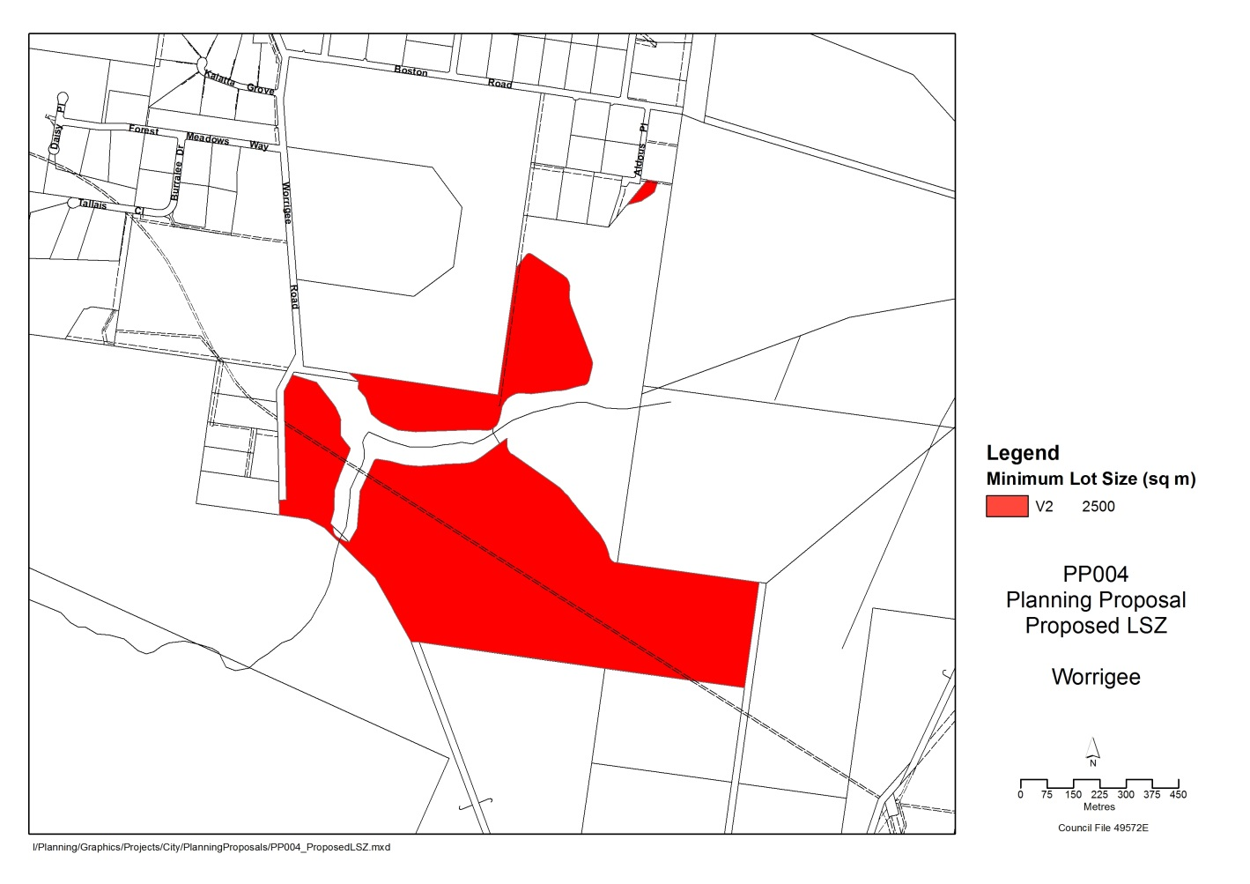

Figure 6 - Proposed Minimum Lot Size

# 4. Justification of objectives, outcomes and processes (Part 3)

The proposed R5 Large Lot Residential Zone is considered to be a more appropriate use of the site, is consistent with adjoining development and sympathetic to the environmental constraints of the land. The PP will also remove any uncertainty about the future use of the subject land.

The intent to rezone the subject land is supported by both URA landowners and Attachment A details the supporting Council resolution.

## 4.1 Need for the Planning Proposal (Section A)

### **4.1.1 Is the Planning Proposal a result of any strategic study or report?**

The Worrigee URA was identified in the Nowra-Bomaderry Structure Plan which was adopted by Council in October 2006 and endorsed by the State Government in early 2008. Development of the Structure Plan involved the completion of a number of preliminary background studies to support rezoning of the subject land such as biodiversity, bushfire and hydrology assessment.

The Structure Plan proposed a golf course/residential development for the Worrigee URA with an approximate lot yield of 392. The subject land was rezoned as part of Shoalhaven LEP 2014 to facilitate this form of development. Since commencement of Shoalhaven LEP 2014, more detailed studies of the URA have been undertaken to support development of a site specific Development Control Plan. These investigations have focused as biodiversity, bushfire, flooding, hydrology, traffic and infrastructure assessment.

The PP now seeks to rezone the land to facilitate large lot residential development on the site with an estimate lot yield of 100. The large lot residential development is considered to be more sympathetic to the flooding constraints of the land, while still providing a new residential development in accordance with the Structure Plan.

4.1.2 Is the Planning Proposal the best means of achieving the objectives or intended outcomes, or is there a better way?

A PP is the only effective planning means to achieve the objectives or intended outcomes of essentially changing the zoning of the URA from R1 General Residential, RE2 Private Recreation to an R5 Large Lot Residential zone and to address a previous error associated with the north eastern corner of the URA.

### 4.2 Relationship to strategic planning framework (Section B)

4.2. 1 Is the Planning Proposal consistent with the objectives and actions of the applicable regional or sub-regional strategy?

South Coast Regional Strategy

The South Coast Regional Strategy (SCRS) provides key regional level guidance applying to the subject land in relation to the provision of suitable land to address the employment and housing needs of the Region.

The PP seeks to implement the SCRS which identifies the need to accommodate some 15,800 new dwellings in vacant land and investigation areas around the Nowra-Bomaderry area such as the Worrigee URA.

The proposal is consistent with the overall aims and objectives of the SCRS.

Draft Illawarra Regional Growth and Infrastructure Plan

The draft Illawarra Regional Growth and Infrastructure Plan (draft Plan) applies to the whole Shoalhaven Local Government Area including the subject land. At the time that this PP was prepared the draft Plan had not been finalised.

The draft Plan identifies areas around Nowra- Bomaderry (as identified in theNowra-Bomaderry Structure Plan) as having potential Greenfield residential capacity to accommodate future population growth. The draft Plan aims to “…continue implementing the integrated delivery framework for West Dapto and Nowra-Bomaderry”.

The proposal is consistent with the draft Illawarra Regional Growth and Infrastructure Plan.

4.2.2 Is the Planning Proposal consistent with a council’s local strategy or other local strategy plan?

Nowra-Bomaderry Structure Plan

The URA is identified in the Nowra-Bomaderry Structure Plan (NBSP) and the PP is consistent with the Plan’s objectives and actions to support residential growth around Nowra and Bomaderry and provide a mix of housing choice to meet the future needs of the community. As detailed earlier the proposed lot yield is significantly less than the figure proposed in the NBSP; however the proposal is a direct response to flooding constraints on site and the surrounding character.

Community Strategic Plan

The PP is broadly consistent with Council’s Community Strategy Plan. The relevant objectives and strategy are detailed below and will be considered in the studies recommended as part of the Council resolution.

Objective 2.2 Population and urban settlement growth that is ecologically sustainable and carefully planned and managed

Objective 2.6 Settlements that are resilient to the unexpected impacts of natural hazards

Strategy 2.4.2 Develop land use and related plans for the sustainable growth of the City which use the core principles of the Growth Management Strategy and ESD principles, also carefully considering community concerns and the character of unique historic townships.

4.2.3 Is the Planning Proposal consistent with applicable State Environmental Planning Policies?

Relevant State Environmental Planning Policies (SEPPs) considered in the preparation of the PP include:

SEPP (Infrastructure) 2007

The PP is likely to result in development classed as traffic generating development in accordance with the SEPP. In order to consider the aims and objectives of the SEPP, the RMS will be consulted as required after the Gateway determination and as part of the detailed studies that are undertaken.

SEPP (Rural Lands) 2008

The relevant s117 direction requires that PP’s which affect land within existing or proposed rural or environmental zones be consistent with the principles of the SEPP. The PP is generally consistent with the SEPP in that a community benefit is anticipated to be achieved through the conservation of the surrounding rural and environmentally sensitive lands.

4.2.4 Is the Planning Proposal consistent with applicable Ministerial Directions (s. 117 directions)?

The PP is consistent with all relevant Section 117 Ministerial Directions as outlined in Attachment D.

## 4.3 Environmental, Social and Economic Impact (Section C)

4.3.1 Is there any likelihood that critical habitat or threatened species, populations or ecological communities, or their habitats, will be adversely affected as a result of the proposal?

No. The purpose of the PP is to rezone land already zoned R1 and previous site studies have identified and zoned environmental characteristics and corridor value of the land as either E2 (Environmental Conservation) or E3 (Environmental Management). These Environmental Protection zones are not proposed to be changed in this PP.

4.3.2 Are there any other likely environmental effects as a result of the Planning Proposal and how are they proposed to be managed?

No. Large parts of the site are identified as being in the Flood Planning Area in Shoalhaven LEP 2014. The PP seeks to facilitate large lot residential development which will allow for development that is more sympathetic to the flood constraints of the land. The associated Development Control Plan Chapter for the site will ensure that any future subdivision of the site will be designed to allow dwellings to be located outside of any high hazard flood areas.

4.3.3 Has the Planning Proposal adequately addressed any social and economic effects?

Yes, the PP is the result of detailed rezoning investigations. The social and economic effects on the future zoning of the land were considered as part of development the *Nowra-Bomaderry Structure Plan*.

4.4 State and Commonwealth Interests (Section D)

4.4.1 Is there adequate public infrastructure for the Planning Proposal?

Yes. Additional public infrastructure will be considered through the subsequent subdivision applications for residential use of the subject site. The site is proposed to have onsite sewerage management systems for each individual residential lot. Further studies will be required to determine the onsite sewage management capability.

4.4.2 What are the views of State and Commonwealth public authorities consulted in accordance with the Gateway determination?

Not applicable, as the proposal has not been given Gateway determination yet. Recognising that the majority of the subject land is zoned R1 it is unlikely that the views of State and Commonwealth public authorities will significantly affect the PP.

# 5. Mapping (Part 4)

The following maps are included in the PP:

* Proposed LZN Overlay
* Proposed LSZ Overlay
* Proposed URA map sheet with no overlay

Additional maps will be provided in the exhibited PP as required by the Gateway determination.

# 6. Community consultation (Part 5)

Community consultation will occur in accordance with the Gateway determination, and it is anticipated that the PP will be exhibited for a minimum period of 28 days.

Public notification of the exhibition will include notification in the local newspaper, and a notice on Council’s website. Hard copies of the PP would be made available at Council’s Administrative Buildings in Nowra.

# 7 Project timeline (Part 6)

The following milestone timeframes are anticipated and will be revised if any significant delays are encountered during the process.

|  |  |
| --- | --- |
| Task | Anticipated Timeframe |
| Commencement date (date of Gateway determination) | July 2015 |
| Completion of Gateway determination requirements – i.e. studies, government agency consultation | July 2015 |
| Public exhibition (minimum 28 days) | August 2015 |
| Post exhibition consideration of Planning Proposal | September/October 2015 |
| Finalisation and notification of Plan | December 2015 |

# Attachment A: Council resolution to prepare a Planning Proposal

**MINUTES OF THE DEVELOPMENT COMMITTEE MEETING HELD ON TUESDAY, 5 AUGUST, 2014 IN THE COUNCIL CHAMBERS, CITY ADMINISTRATIVE CENTRE, BRIDGE ROAD, NOWRA COMMENCING AT 6.01 PM**

1. Worrigee Urban Release Area – Commencement of Processes Under Part 6  
 File 49004E, 49572E, 49573E (PDR)

MOTION: Moved: Watson / Second: Baptist

RESOLVED that in accordance with the Committee’s delegated authority from Council, that Council:

a) Commence the process under Part 6 (Urban Release Areas) of the Shoalhaven Local Environmental Plan 2014 and prepare an Infrastructure Plan, Development Control Plan and Planning Proposal to reflect the revised larger lot layout for the site.

b) Receive further update reports on this matter as required.

CARRIED

FOR: Tribe, Robertson, Kearney, Anstiss, White, Wells, Baptist, Findley, Guile, Watson, Kitchener, Gash, Russ Pigg.

AGAINST: Nil

# Attachment B: Worrigee URA Flood Study

## Attachment C: State Environmental Planning Policies

Draft LEP Checklist – State Environmental Planning Policies (SEPPs) – Worrigee URA

|  |  |  |  |  |  |
| --- | --- | --- | --- | --- | --- |
| **Draft LEP Checklist**  **State Environmental Planning Policies** | | | | | |
| **SEPP** | **Date** | **Name** | **Inconsistent** | **Not**  **Inconsistent** | **Not**  **Applicable** |
| 6 | 10.12.82 | Number of storeys in a building |  |  | ✓ |
| 14 | 12.12.85 | Coastal wetlands |  |  | ✓ |
| 21 | 24.4.92 | Caravan parks |  | ✓ |  |
| 26 | 5.2.88 | Littoral rainforests |  |  | ✓ |
| 30 | 8.12.89 | Intensive agriculture |  | ✓ |  |
| 32 | 15.11.91 | Urban consolidation (Redevelopment of urban land) |  |  | ✓ |
| 33 | 13.3.92 | Hazardous and Offensive development |  | ✓ |  |
| 36 | 16.7.93 | Manufactured home estates |  | ✓ |  |
| 44 | 6.1.95 | Koala habitat protection |  | ✓ |  |
| 50 | 10.11.97 | Canal estate development |  | ✓ |  |
| 55 | 28.8.98 | Remediation of land |  | ✓ |  |
| 62 | 25.9.00 | Sustainable aquaculture |  | ✓ |  |
| 64 | 16.3.01 | Advertising and signage |  | ✓ |  |
| 65 | 26.7.02 | Design quality of residential flat development |  |  | ✓ |
| 71 | 1.11.02 | Coastal protection |  |  | ✓ |
| -- | 31.3.04 | Housing for Seniors or People with a Disability 2004 |  |  | ✓ |
| -- | 25.6.04 | BASIX : 2004 |  |  | ✓ |
| -- | 1.8.05 | Major Development 2005 |  | ✓ |  |
| -- | 16.2.07 | Mining, Petroleum Production and Extractive Industries 2007 |  | ✓ |  |
| -- | 26.10.07 | [Temporary Structures 2007](http://www.legislation.nsw.gov.au/summarize/inforce/s/1/?EPITITLE=%22State%20Environmental%20Planning%20Policy%20(Temporary%20Structures%20and%20Places%20of%20Public%20Entertainment)%202007%22&nohits=y) |  | ✓ |  |
| -- | 1.1.08 | Infrastructure 2007 |  | ✓ |  |
| -- | 9.5.08 | Rural Lands 2008 |  | ✓ |  |
| -- | 12.12.08 | Exempt and Complying Development Codes 2008 |  | ✓ |  |
| -- | 31.7.09 | Affordable Rental Housing 2009 |  | ✓ |  |
| -- | 21.1.11 | Sydney Drinking Water Catchment 2011 |  | ✓ |  |
| -- | 28.9.11 | State and Regional Development 2011 |  | ✓ |  |

## Attachment D: Checklist of Ministerial Directions

Draft LEP Checklist – Section 117(2) Directions – Worrigee Urban Release Area

| **Direction No:** | **Subject** | **Applies?** | **Relevant?** | **Consistent?** | **Comment** |
| --- | --- | --- | --- | --- | --- |
| **1** | **Employment and Resources** | | | | |
| 1.1 | Business and Industrial Zones | **N** |  |  |  |
| 1.2 | Rural Zones | **Y** | **Y** | **Y** | The PP seeks to rezone a small part of the land from a rural zone to an R5 Large Lot Residential, to allow for a secondary access into the URA, and therefore may be considered inconsistent with this direction. However, as the PP is justified by a strategy, being the Nowra-Bomaderry Structure Plan, the PP is considered to be consistent with the terms of this direction.  The PP only seeks to rezone a small portion of the land from a rural zone, and any inconsistency with this direction would be considered minor. |
| 1.3 | Mining, Petroleum Production and Extractive Industries | **N** |  |  |  |
| 1.4 | Oyster Aquaculture | **N** |  |  |  |
| 1.5 | Rural lands | **Y** | **Y** | **Y** | The PP is consistent with this Direction as it is it conforms with the Rural Planning Principles listed in State Environmental Planning Policy (Rural Lands) 2008.  The PP seeks to make a minor change to the rural zone boundary and rezone approximately 2,571 m2 of rural land to R5 Large Lot Residential (consistent with the adjoining R5 land) following the edge of the Flood Planning Area. This minor change to the zone boundary will allow for the secondary access into the URA to be formalised. |
| **2** |  | | | | |
| 2.1 | Environmental Protection Zones | **Y** | **Y** | **Y** | The PP is consistent with this direction as it is not proposing to reduce the environmental protection standards that apply to the land. |
| 2.2 | Coastal Protection | **N** |  |  |  |
| 2.3 | Heritage Conservation | **Y** | **N** | **Y** | The PP is consistent, as although it does not propose to contain provisions for conservation of heritage items etc., it will amend the principle LEP which includes relevant provisions. |
| 2.4 | Recreation Vehicle Area | **Y** | **N** | **Y** | The PP will not enable the land to be developed for the purpose of a recreation vehicle area. |
| **3** | **Housing, Infrastructure and Urban Development** | | | | |
| 3.1 | Residential Zones | **Y** | **Y** | **Y** | The PP will broaden the choice of building types within the Nowra-Bomaderry Urban Release Areas. The proposal will allow for large lot residential development, which is sympathetic to the environmental constraints of the land, and provides a different housing choice to other URA’s in the Nowra-Bomaderry area.  The large lot residential development will also allow for onsite effluent disposal, eliminating the need to extend costly sewerage mains to the site. |
| 3.2 | Caravan Parks and Manufactured Home Estates | **Y** | **N** | **Y** |  |
| 3.3 | Home Occupations | **Y** | **Y** | **Y** | Home occupations are permissible without consent in the R5 zone under LEP 2014. |
| 3.4 | Integrating Land Use and Transport | **Y** | **Y** | **Y** | The PP seeks to rezone the land from a small lot, to a large lot residential zone and is considered to be consistent with this direction. The PP is justified by a strategy, being the Nowra-Bomaderry Structure Plan which gives consideration to the objectives of the direction, identifies the subject land and was endorsed by the Department of Planning and Environment. |
| 3.5 | Development Near Licensed Aerodromes | **N** |  |  |  |
| 3.6 | Shooting Ranges | **N** |  |  |  |
| **4** | **Hazard and Risk** | | | | |
| 4.1 | Acid Sulphate Soils | **Y** | **Y** | **Y** | The PP is considered consistent with this direction as it does not propose any intensification of the land use on the site. |
| 4.2 | Mine Subsidence and Unstable Land | **N** |  |  |  |
| 4.3 | Flood Prone Land | **Y** | **Y** | **Y** | The PP seeks to rezone flood prone land from part R1 and part RE2 to an R5 Large Lot residential zone. The large lot residential zone will allow for future subdivisions to be designed to allow dwellings to be located outside of any high hazard flood areas. |
| 4.4 | Planning for Bushfire Protection | **Y** | **Y** | **Y** | The majority of the area intended to be rezoned for development by the PP is outside the bushfire prone areas of the subject site. Consultation with NSW RFS has already occurred to ensure that development in the area which is bushfire prone will be consistent with Planning for Bushfire Protection. However, Council will consult with the Commissioner of the NSW Rural Fire Service following receipt of a Gateway Determination as per this direction. |
| **5** | **Regional Planning** | | | | |
| 5.1 | Implementation of Regional Strategies | **Y** | **Y** | **Y** | The PP is consistent with the South Coast Regional Strategy and draft Illawarra Regional Growth and Infrastructure Plan. |
| 5.2 | Sydney Drinking Water Catchments | **N** |  |  |  |
| 5.3 | Farmland of State & Regional Significance on Far North Coast | **N** |  |  |  |
| 5.4 | Commercial & Retail Development, Pacific Hwy | **N** |  |  |  |
| 5.8 | 2nd Sydney Airport: Badgerys Creek | **N** |  |  |  |
| 5.9 | North West Rail Link Corridor Strategy | **N** |  |  |  |
| **6** | **Local Plan Making** | | | | |
| 6.1 | Approval and Referral Requirements | **Y** | **N** | **Y** | The PP does not include provisions related to the concurrence, consultation or referral of development applications or identify development as designated development. |
| 6.2 | Reserving Land for Public Purposes | **Y** | **N** | **Y** | The PP does not create, alter, or reduce existing zonings or reservations of land for public purposes. Council has not been requested by a Minister or public authority to include provisions to reserve land for a public purpose. |
| 6.3 | Site Specific Provisions | **Y** | **Y** | **Y** |  |